**1. Create DynamoDB instance and initial Time-to-live**

Step 1: go Amazon DynamoDB page

Step 2: Create table

Step 3: Create table

Step 4: Turn on DynamoDB stream detail

Navigate to Exports and streams

Step 5: Turn on, select New and Old images

Step 6: Turn on stream

Step 7: turn on Time-to-live: navigate to Additional Settings

Step 8 Turn on

TTL atribute name: ttl

Step 9 Turn on TTL

Step 10: Insert data to asm2-ccp302x table on DynamoDB instance

Step 11: Create item

Step 12

**2. Create DynamoDB Stream to active Lambda Function**

Step 13

**3. Create lambda function to create Reminder**

Step 14 Navigate to AWS Lambda Service

Step 15 Create a function

Function name: asm2-put-reminder

Runtime: Python 3.9

Step 16

Select: Use an existing role

Lambda_dynamodb_role

Step 17 Create function

Step 18: code for put reminder to DynamoDB

Step 19 Click Deploy: Deploy successfully

Step 20: Put to DynamoDB successfully

4. Create lambda function to get Reminder by ID

Step 21 click function

Step 22: create function

Function name: asm2-get-reminder

Runtime: python 3.9

Step 23

Step 24 Create function

Step 25 Deploy code get reminder by ID

Step 26 Click test

Step 27 Save and click Test

Result: ID: 1, message: Publish next Youtube Video

**5. Create Lambda funciton get reminder by User_email**

Step 28 navigate to function and Create function

Step 29

Step 30

Step 31 Deploy to code get reminder by user_email

Step 32 click Test

Step 33 click Test to result below

**6. Using API Gateway create REST API**

Step 34 Navigate to API Gateway and select REST API

Step 35 Click Build

Step 36 Create API

Step 37 Create resource

Step 38 Create resource

Step 39 Create method

Step 40 select lambda function and put-reminder and create method

Step 41

Step 42: click Deploy API

Step 43

Step 44 using postman check to PUT data to DynamoDB

Step 45 Result

ID: 4

Message: Get lunch

Step 46 Create API get reminder by ID

Step 47

Step 48 Create method

Step 49 select Lambda function and choose get reminder by id

Step 50

Step 51 Deploy API

Step 52

Step 53: need to change Authorization : AWS IAM

Step 54

Step 55: result

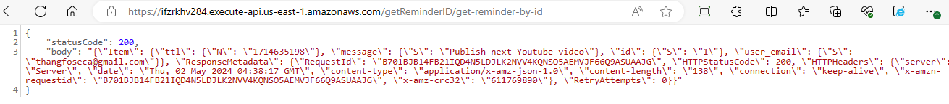

Step 56:

Step 57

Step 58 Create method

Step 59: select lambda function with get-reminder-by-user

Step 60: need to change Authorization: aws iam

Step 61

Step 62

Step 63: click Deploy API

Step 64

Step 65

**7. Create Lambda Function to send Email**

step 66: create lambda send email when item of dynamoDB expired

Step 67 create function

Step 68 deploy code

Step 69 Add trigger

Step 70

**8. Save information of reminders was send**

Step 71 Navigate to Amazon Simple email service page and select identities

Step 72 Create identity

Step 73

Step 74 verification

Step 75

Step 76

Step 77: create lambda function send email when item on DynamoDB has expired

Step 78

Step 79

Step 80: click Deploy

Step 81 click Add Trigger

Step 82

Step 83 click Add

Step 84 check the system send email when item expired

Step 85

Step 86 Check email

Email

**9. Using CloudFormation to Automatic architecting**

Check file template.yml according to attachment.

**10. Edit Reminder**

Step 87 create lambda function

Step 88 Create method Read and Update reminder

Step 89

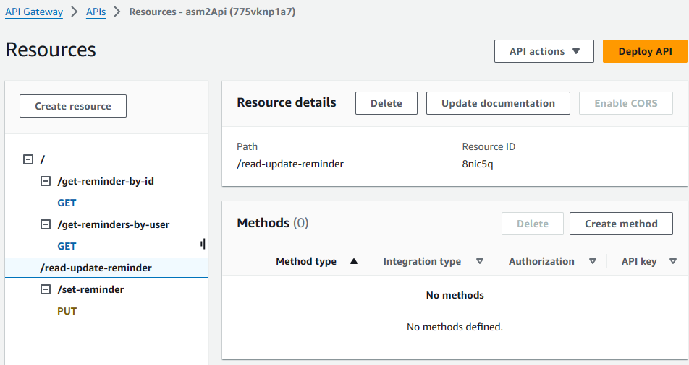

Step 90 Create method

Step 91 Deploy API

Step 92: setup API key

Step 93

Step 94: check result read and update reminder

Step 95: update reminder

Step 96: I will update id=3 with message = “Play football”

Step 97: result

